April 16th, 2006
Gavin, Nadine

Nadine, as you grumbled about not getting a ‘proper’ letter, I will go back to writing one! Still not that much to report though. Haven’t seen Leonie this past week. She has a friend who came from Zambia where she is spending a year. Her friend is staying with Leonie for the Easter holidays and sleeping on the floor of her room. Leonie is showing her around HK. But the weather is not that good. Much cooler – yesterday was only about 16⁰C – and low cloud and occasional drizzle. They wanted to go to Tai Long Wan (the big beach beyond Sai Kung that we have walked to occasionally) today but will go to Lamma Island instead. Her friend leaves tomorrow about midnight.
Tai Long Wan (‘smaller beach in foreground)

Saw an Interesting documentary on the 'Great Escape' from Stalag Luft III towards the end of WWII and how 50 of the 79 escapees were shot by the Gestapo on the direct orders of Hitler. They were airmen, mainly from Britain (some US airmen were also involved but most had been moved to another camp as more POWs were arriving) many of whom had been moved there having escaped from other camps and been caught. The Germans thought they had made the camp escape-proof. Only 3 escapees made it back. There is a clear distinction between the Nazis (e.g. Gestapo) and the non-Nazi Germans, such as the camp staff. For example, the camp commandant was a WWI veteran and in WWII joined the Luftwaffe as it was the least influenced by the Nazis. The commandant also allowed the POWs to erect a memorial (just outside the camp) to those who were killed by the Gestapo, a memorial that still stands.
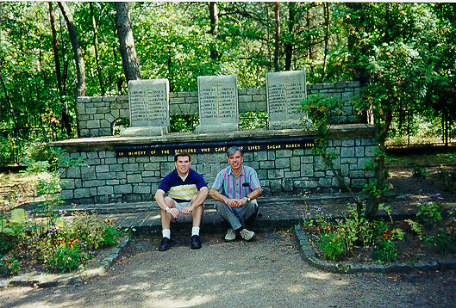
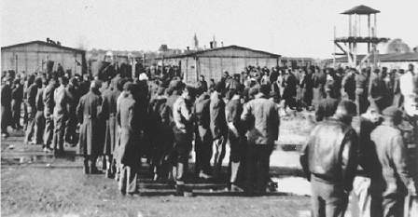

The memorial POWs in Stalag Luft III
Last Monday, Leonie was sick all day - she believed she has meningitis and that she would have to go into hospital! Report the same day that Bush et al are planning to strike Iran! Really!! I have been reading an article in the latest TIME magazine by a retired officer that severely criticises the Iraq war. It was written by US Marine Lt. General Greg Newbold. You might know of him, Gavin.
Gavin, you mentioned watching the TV programme ‘Top Gear’ and I mentioned I had seen parts of it on HK TV. However, what I had seen was a similar programme called 'Fifth Gear'! However, I have watched Top Gear, but on the BBC channel.
Last Thursday, I went to clinic to change the date for an appointment which had been scheduled before my operation. However, while waiting to change it, the doctor involved walked past so I spoke to him. Then I didn't change the appointment as the clinic is independent of hospital and the appointment had nothing to do with the hospital operation as I had thought.
Went for a longer run yesterday. Much cooler; as I mentioned above. Ran from CU up Ma On Shan and back. Disappointing – took 3 hr 5 min, which was 11 min slower than last year. And last year I also had that bad fall which would have added several minutes. However, the time was the same as the one before that in 2003.
Nadine – quite impressed about the work with the monkeys that you are doing. In your e-mail, you used a lot of terms that I have no idea the meaning of!

Sent an e-mail to Stanford to ask them to send me the issues of ‘The Hound of the Baskervilles’ by Sherlock Holmes. As in previous years, they had been issuing copies of the original issues weekly but for overseas people they send them all in one package when the weekly issues are complete.
That’s about it for now.
Cheers

